How has political news consumption changed over time in the United Kingdom and Italy, and how is it related to individuals’ political interest?

Introduction

Political news plays a central role in democratic life by providing citizens with information about public affairs, political actors, and governing institutions. Regular exposure to political news has been consistently associated with higher political knowledge, stronger political interest, and greater political participation (Lee, Nanz and Heiss, 2022). However, engagement with political news is uneven across Europe, varying substantially by country, social group, and individual levels of political interest (Grasso and Smith, 2022; Ahmed and Gil-Lopez, 2022). In recent years, these differences have attracted growing attention amid concerns about declining news consumption, selective exposure, and political disengagement in increasingly fragmented media environments (Shehata, Ekström and Tryggvason, 2024).
Political interest is one of the strongest individual-level predictors of political news consumption. Individuals with higher political interest are more likely to actively seek out news and follow political developments, while those with lower interest tend to disengage from political content altogether (Espeland, 2024). As such, political interest is a key variable for understanding not only how much political news people consume, but also which groups remain engaged with political information.
Importantly, patterns of political news consumption are not static. Political events, media system changes, and broader social transformations can reshape how citizens engage with news over time. This study therefore examines change across ESS Rounds 8, 9, and 10 (2016–2020), a period characterised by heightened political debate across Europe. Focusing on the United Kingdom and Italy allows for a comparative assessment of how political news consumption and political interest interact across two countries with distinct political cultures and media environments.

Research Question
Main
How has political news consumption changed over time in the United Kingdom and Italy, and how is it related to individuals’ political interest?
Supporting sub-questions
- How has political news consumption changed across ESS Rounds 8–10 in the UK and Italy?
- Are individuals with higher political interest more likely to consume political news?
- Does the relationship between political interest and news consumption differ by country?
- Do socio-demographic factors (gender, age, education) help explain differences in political interest linked to news consumption?

Data source and methodology
Data source
This study uses data from the European Social Survey (ESS), a biennial cross-national survey designed to measure attitudes, beliefs, and behaviour across European populations. Data were obtained from the ESS Data Portal for Rounds 8, 9, and 10, selected to capture recent patterns in political news consumption while maintaining consistency in question wording and variable availability. The analysis focuses exclusively on respondents from the United Kingdom and Italy, enabling a focused comparison between two countries with distinct political cultures and media environments.
Variables
Political news consumption was measured using nwspol, which records the time respondents spend watching, reading, or listening to political news on a typical day. Political interest was measured using polintr, a four-category self-reported measure ranging from “very interested” to “not at all interested.”
Three socio-demographic variables were included for bivariate analysis: gender (gndr), age (agea), and educational attainment (edulvlb). Gender was used as provided in the dataset, while age and education were recoded into broader categories to improve interpretability and ensure sufficient sample sizes within each group. All analyses applied the ESS post-stratification population weight (pspwght) to correct for sampling design and population structure and to produce nationally representative estimates (see Table 1).
Table 1: Varibale definitions
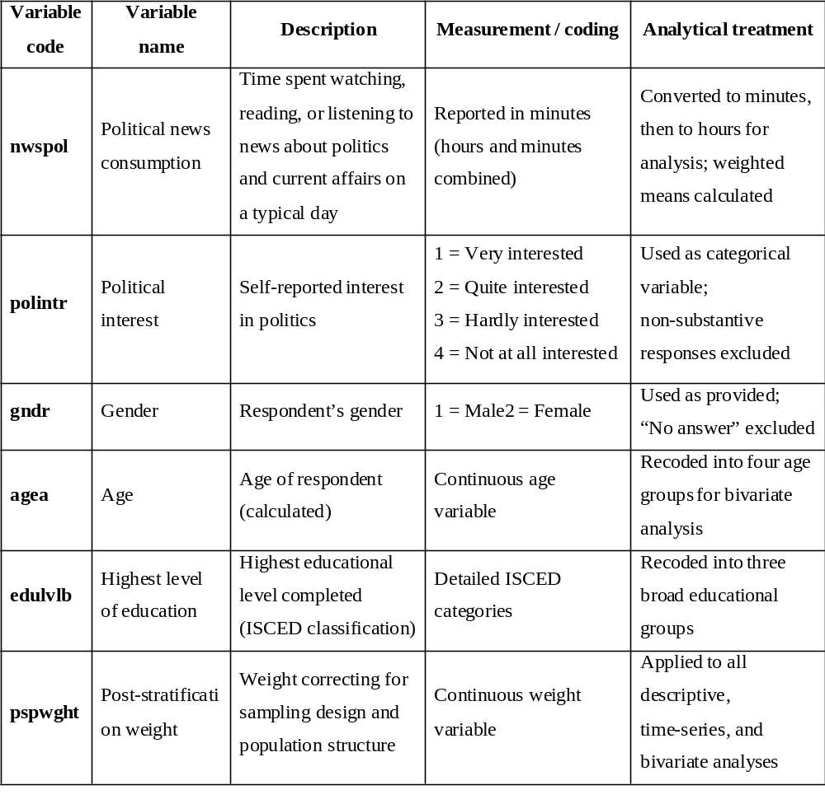
Data preparation and transformations
Datasets from Rounds 8, 9, and 10 were first filtered to retain only respondents from the United Kingdom and Italy. Variables were checked for consistency across rounds, and non-substantive responses, including refusals, “don’t know,” and no-answer categories, were excluded. Political news consumption (nwspol), originally recorded in minutes, was converted into hours to aid interpretation. Weighted mean values were then calculated by country, survey round, and political interest category. Age (agea) was recoded into four life-stage groups, while educational attainment (edulvlb), originally coded using detailed ISCED categories, was recoded into three educational groups (low, medium, and high).

Data Analysis Plan
Descriptive statistics summarised levels of political news consumption and political interest in each country. Time-series analysis examined changes in political news consumption across ESS Rounds 8, 9, and 10. Bivariate analysis used weighted cross-tabulations and correlation analysis to explore associations between political interest, political news consumption, and socio-demographic characteristics. All data preparation and analyses were conducted using SPSS and Microsoft Excel.

Results
Descriptive Result of Variables
Figure 1 shows the average weighted statistics of political news consumption between United Kingdom and Italy. It was observed that respondents in Italy (M= 183.8 minutes) spend considerably more time consuming news about politics and current affairs than those in the UK (M= 93.8 minutes). The standard deviations are relatively high for both countries (222.2 minutes for the UK and 302.5 minutes for Italy), indicating considerable variability in news consumption across respondents.

Figure 1: Average political news comsumption

Figure 2 shows the distribution of political interest among respondents in the United Kingdom and Italy. In the UK, the largest share of respondents reported being quite interested in politics (42.8%), followed by those who are hardly interested (24.2%), very interested (17.5%), and not at all interested (15.5%).
In contrast, the Italian sample shows a different pattern, with hardly interested respondents forming the largest group (39.5%), followed by those not at all interested (30.6%), quite interested (24.8%), and very interested (5.1%).

Figure 2: Distribution of political interest by country

In the United Kingdom, time spent listening to political news remains low and relatively stable across the three rounds. The average increases slightly from 1.55 in Round 8 to 1.63 in Round 9, before declining to 1.45 in Round 10. Overall, there is no sustained growth, and listening time returns to roughly its initial level by Round 10.
In Italy, average listening time is consistently higher than in the UK in all three rounds. However, a clear downward trend is observed over time, falling from 3.62 in Round 8 to 2.93 in Round 9 and further to 2.70 in Round 10.

Figure 3: Average daily political news consumption over time in the UK and Italy

In the United Kingdom, average scores decrease steadily from Round 8 to Round 10. The decline is most visible among respondents who report being very interested in politics, falling from 2.23 in ESS 8 to 1.95 in ESS 10. Similar downward trends are observed among those who are quite interested, hardly interested, and not at all interested, indicating a general reduction in political interest over time.
In Italy, political interest levels are consistently higher than in the UK across all rounds and categories. Respondents who are very interested show the highest values, though these also decline slightly from 3.82 in ESS 8 to 3.60 in ESS 10.

Figure 4: Chart showing the political interest of participant in UK and Italy Across ESS Round 8, 9 and 10
Bi-variate Analysis
Figure 5 presents the gender distribution of respondents who reported being very interested in politics across ESS Rounds 8, 9, and 10.
In Round 8, 58.4% of respondents who were very interested in politics were male, compared to 41.6% female, indicating higher political interest among men. In Round 9, this difference became more pronounced, with 64.0% male and 36.0% female among those reporting very high political interest. In Round 10, males still accounted for a larger share of respondents who were very interested in politics (54.9%), although the proportion of females increased to 45.1%.
Across all three rounds, males consistently showed higher levels of very strong political interest than females, with the gender gap narrowing slightly in the most recent round.

Figure 5: Chart showing gender distribution of respondents who reported interest in politics across ESS Rounds 8, 9, and 10.

Figure 6 shows the age distribution of respondents who showed interest in politics across ESS Rounds 8, 9, and 10.
In Round 8, political interest increased clearly with age. Only 11.0% of those who were very interested in politics were aged 15–29, compared with 21.8% aged 30–44, 24.7% aged 45–59, and a much larger share (42.5%) aged 60 and above.
The same pattern appears in Round 9. Respondents aged 60+ again formed the largest group among those very interested in politics (45.3%), followed by those aged 45–59 (27.6%). Younger respondents remained underrepresented, with only 7.0% in the 15–29 age group.
In Round 10, this age gradient became even stronger. Nearly 46.0% of respondents who were very interested in politics were aged 60 and above, while only 5.7% were aged 15–29. The 45–59 age group also accounted for a substantial share (29.1%).
Overall, across all three rounds, higher age is strongly associated with higher political interest

Figure 6a: Chart showing age distribution of respondents who reported interest in politics in ESS Rounds 8.

Figure 6b: Chart showing age distribution of respondents who reported interest in politics in ESS Rounds 9.

Figure 6c: Chart showing age distribution of respondents who reported interest in politics in ESS Rounds 9.
Figure 7 shows the distribution of respondents who showed interest in politics across educational levels in ESS Rounds 8, 9, and 10. In Round 8, respondents with higher education made up the largest share of those who were very interested in politics (54.4%). This was followed by those with post-secondary education (25.8%), while respondents with lower education accounted for a much smaller share (18.9%). The “other” category was negligible (0.9%).
The same pattern is observed in Round 9. More than half of respondents who were very interested in politics had higher education (55.9%), compared with 25.6% with post-secondary education and 16.5% with lower education.
In Round 10, the association became even stronger. Nearly 61.0% of respondents who reported being very interested in politics had higher education, while only 14.9% had lower education. Post-secondary education continued to occupy a middle position (24.3%).
Across all three rounds, educational level shows a clear and consistent relationship with political interest. Respondents with higher education consistently showed the highest levels of very strong political interest, while those with lower education showed the lowest.

Figure 7a: Chart showing the distribution of respondents who showed interest in politics across educational levels in ESS Rounds 8.

Figure 7b: Chart showing the distribution of respondents who showed interest in politics across educational levels in ESS Rounds 9.

Figure 7c: Chart showing the distribution of respondents who showed interest in politics across educational levels in ESS Rounds 10.
Table 2 presents the Spearman’s rank correlations between political interest, political news consumption, and key socio-demographic variables (age group, educational level, and gender).
A weak but statistically significant positive correlation was found between political interest and political news consumption (ρ = 0.053; p < 0.001), indicating that respondents who reported higher political interest tended to spend slightly more time consuming political news.
Political interest showed significant associations with all three socio-demographic variables. There was a moderate negative correlation between political interest and age group (ρ = −0.219; p < 0.001), indicating that political interest increased with age. Political interest was also moderately and negatively correlated with educational level (ρ = −0.331; p < 0.001), showing that respondents with higher educational attainment reported higher political interest. In addition, a weak but significant correlation was observed between political interest and gender (ρ = 0.042; p < 0.001), reflecting small gender differences in political interest.
Political news consumption was also significantly related to socio-demographic characteristics. A weak positive correlation was found between political news consumption and age group (ρ = 0.071; p < 0.001), indicating that older respondents spent slightly more time consuming political news. Political news consumption was weakly but significantly correlated with gender (ρ = −0.086; p < 0.001), showing differences in news consumption between males and females. However, there was no statistically significant relationship between political news consumption and educational level (ρ = −0.015; p = 0.091).

Table 2: Spearman’s Rank Correlation Bteween Political Interest, Political News Consumption, Age, Gender and Educational Level (N=12,767)
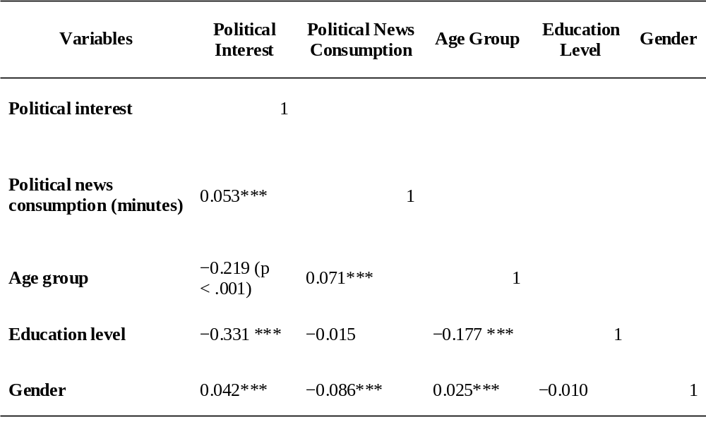
Note. Values are Spearman’s rho (ρ).
*** p < .001. Non-significant correlations are shown without stars.

Study Rationale
Political news plays a central role in democratic life by shaping citizens’ understanding of public affairs and their capacity to engage politically. However, patterns of political news consumption are not evenly distributed across societies, nor are they stable over time. Concerns about declining political engagement and unequal access to information make it important to examine not only how much political news people consume, but also who consumes it and how this has changed in recent years.
This study set out to explore how political news consumption has evolved over time in the United Kingdom and Italy, and how it relates to individuals’ levels of political interest. These two countries were selected because they differ in media systems and political cultures, allowing for meaningful comparison. The focus on ESS Rounds 8, 9, and 10 enables the analysis to capture recent trends before and after major political and social developments in Europe.
The analysis was guided by three main assumptions: first, that individuals who express higher political interest spend more time consuming political news; second, that political interest varies systematically by age, gender, and education; and third, that patterns of news consumption may change over time. The findings largely support these assumptions, showing clear and consistent differences across socio-demographic groups and between countries, while also revealing a general decline in time spent on political news across rounds.

Summary of Findings
This study examined changes in political news consumption over time in the United Kingdom and Italy, and how these patterns relate to individuals’ political interest, using data from the European Social Survey Rounds 8, 9, and 10. The findings reveal clear cross-national differences alongside strong associations between political interest and socio-demographic characteristics.
Descriptive results show that respondents in Italy consistently spent more time consuming political news than those in the United Kingdom. Political interest also differed across countries, with UK respondents more frequently reporting being “quite interested” in politics, while Italian respondents were more concentrated in lower interest categories.
Time-series analysis indicated a general decline in average time spent consuming political news across survey rounds in both countries. Although Italy maintained higher overall levels of political news consumption, the downward trend was evident in both contexts, pointing to a gradual reduction in daily engagement with political news.
Bivariate analyses revealed clear social patterning in political interest. Men consistently made up a larger share of those who reported being very interested in politics across all rounds. Age was also important, with respondents aged 60 and above showing the highest levels of strong political interest. Educational attainment showed the strongest and most consistent association, as respondents with higher education dominated the “very interested” category throughout the period.
The findings point to structural inequalities in political engagement that persist over time. Political news consumption and strong political interest are concentrated among older, male, and highly educated groups, while younger and less educated respondents remain consistently underrepresented among those most engaged. Combined with the observed decline in political news consumption across rounds, this raises serious concerns about the long-term inclusiveness of democratic participation. If large sections of the population are disengaging from political news, this may weaken informed citizenship and widen gaps in political voice. These results highlight the need for further research into how changing media environments, particularly digital and social media platforms, shape political engagement among younger and lower-education groups. Future studies could also examine whether alternative forms of news exposure compensate for declining traditional news use, or whether disengagement reflects a deeper erosion of trust and interest in formal politics.

References
Ahmed, S. and Gil-Lopez, T., 2022. Incidental news exposure on social media and political participation gaps: Unraveling the role of education and social networks. Telematics and Informatics, 68, p.101764.
Espeland, E., 2024. The Dynamics of Political Interest and News Media Avoidance: A Generational and Longitudinal Perspective. Journalism Studies, 25(12), pp.1476-1497.
Grasso, M. and Smith, K., 2022. Gender inequalities in political participation and political engagement among young people in Europe: Are young women less politically engaged than young men?. Politics, 42(1), pp.39-57.
Lee, S., Nanz, A. and Heiss, R., 2022. Platform-dependent effects of incidental exposure to political news on political knowledge and political participation. Computers in Human Behavior, 127, p.107048.
Shehata, A., Ekström, M. and Tryggvason, P.O., 2024. Selective exposure and new political cleavages: Media use and ideological reinforcement over time. The International Journal of Press/Politics, 29(3), pp.733-754.

